Appendix 5 Impulse Response Functions for government investment and transfer shocks

The effect of government investment on GDP is more favourable than that of a government consumption shock (see figure A5.1), because government investment has a positive supply effect. Because of this the effect is also less inflationary and therefore requires a smaller interest rate response of the central bank. However one should notice that the government investment multiplier hinges importantly on the output elasticity of public capital which is not estimated. The parameter is calibrated such as to obtain a marginal product of public capital equal to the marginal product of private capital in the steady state.

Figure A5.2 shows the responses to a government transfer shock. The increase in transfers raises disposable incomes and boosts liquidity-constrained consumption C^{k} directly. There is a negative impact on consumption of non liquidity-constrained consumers, but this is much smaller and aggregate consumption is positively affected by the transfer shock. Again, fiscal policy crowds out private investment.

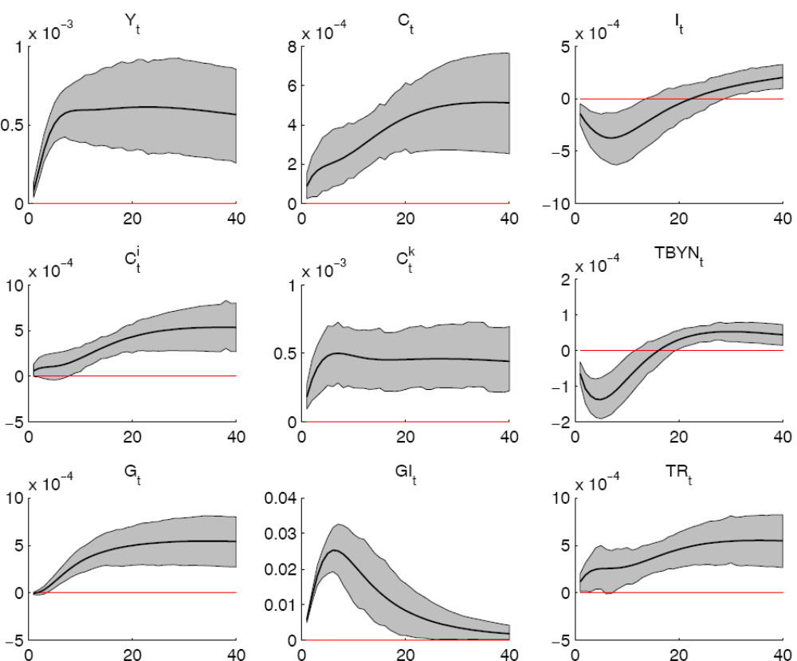
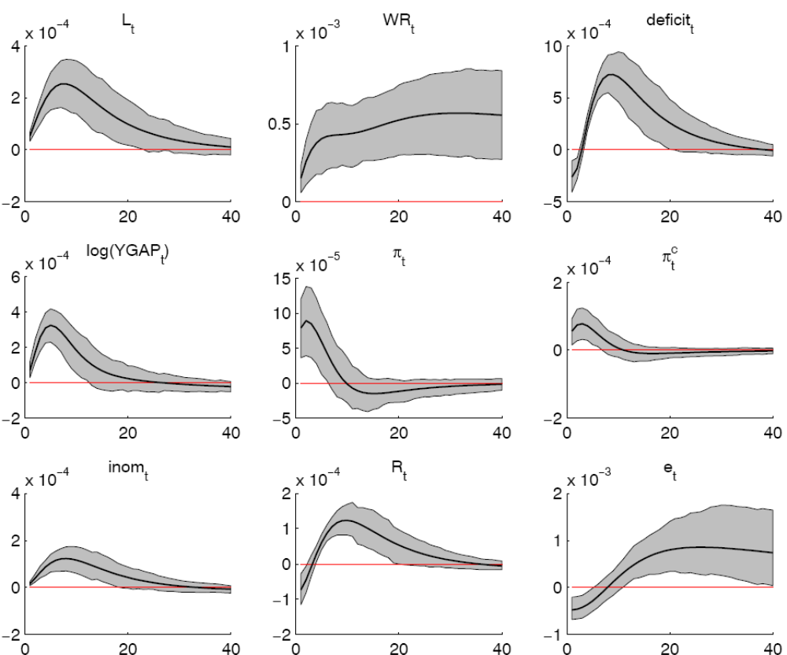

FIGURE A5.1 Response to a government investment shock.

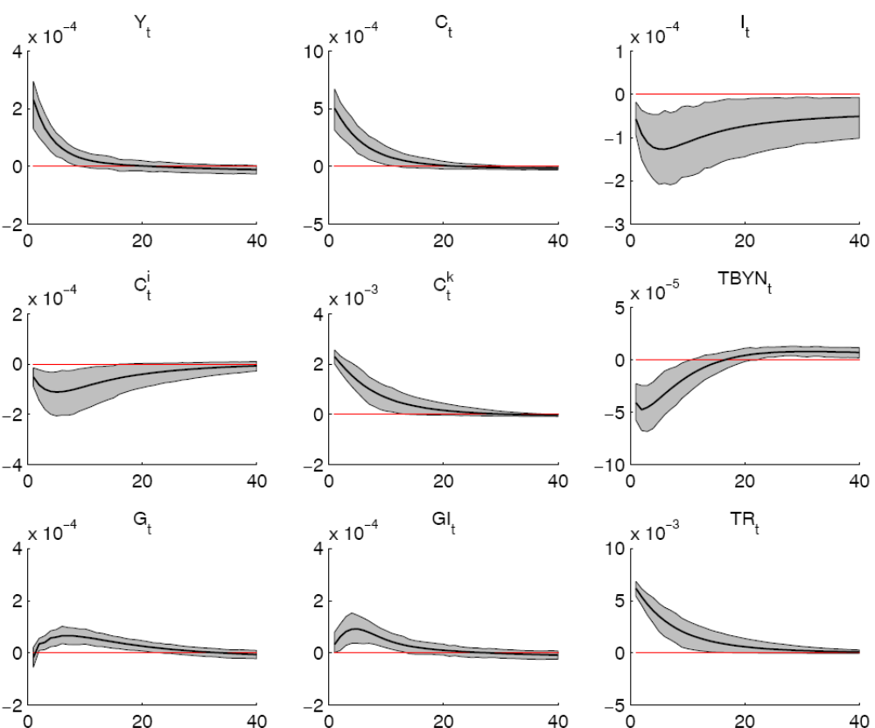

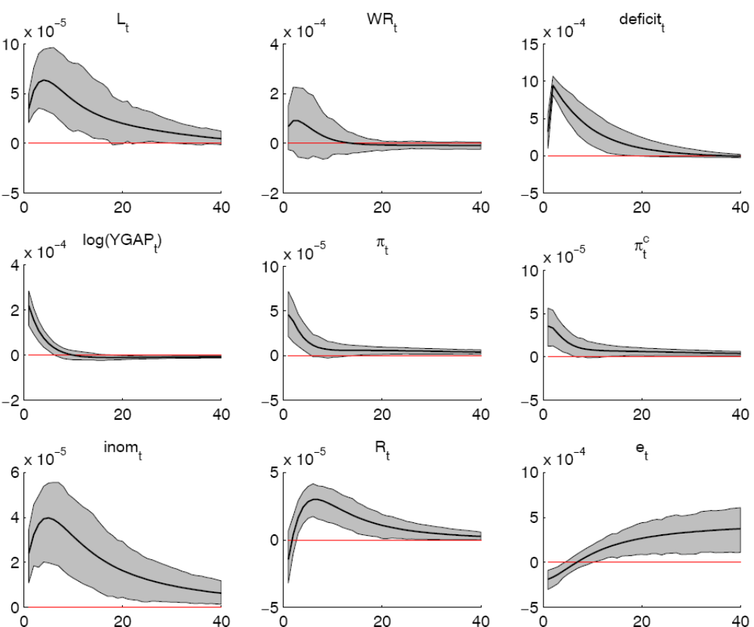

FIGURE A5.2 Response to a government transfers shock.

